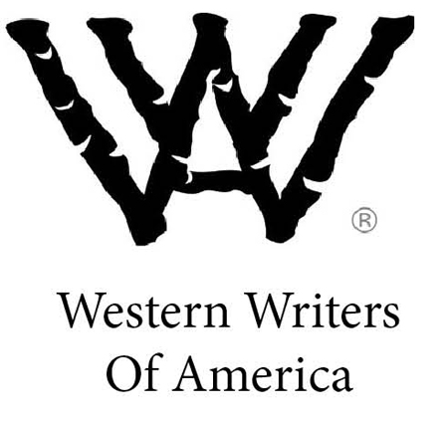
www.westernwriters.org

For Immediate Release

Contact: Candy Moulton, WWA executive director, wwa.moulton@gmail.com, (307) 329-8942

Western authors to discuss
Literature of the American West

in Cody symposium

ENCAMPMENT, Wyo. – Emmy Award-winning scriptwriter and film producer Kirk Ellis and best-selling novelists W. Michael Gear and Kathleen O’Neal Gear will discuss writing about the American West on Thursday,
April 19, at the Buffalo Bill Center of the West in Cody, Wyoming.
“Landscape of Dreams: The Creative West” is Western Writers of America’s fourth James Ersfeld Western Writing Symposium. The free event is scheduled to start at 7 p.m. at the Coe Auditorium.
The authors will share their thoughts on creativity, the lure of the West, fiction and film and respond to audience comments and questions.
The intent of the program is to encourage people in the writing field, with a focus on the Western genre. Western Writers of America, which was founded in 1953 to promote and honor literature about the West, holds the Ersfeld symposium at various locations. Past programs have been in Denver; Dodge City, Kansas; and Santa Fe, New Mexico.
Ellis, the current president of Western Writers of America, is an Emmy-, Spur- and Western Heritage Wrangler-award winning screenwriter whose credits include “Anne Frank,” “Into the West” and “John Adams.” Programs that Ellis has written or produced have garnered a total of 50 Emmy nominations.
The Gears have written more than 60 novels, including historicals, Westerns, thrillers, mysteries and science fiction. They are best known for their “North America’s Forgotten Past” series, better known as the “People” books, a series of 26 novels about North America’s pre-contact civilizations.
The Gears are New York Times, USA Today and international bestselling authors with more than 17 million copies in print and have been translated into 29 languages. They live outside of Thermopolis, Wyoming, where they raise trophy-winning bison. Michael’s epic Civil War novel, “This Scorched Earth,” is forthcoming in April. Kathleen’s next book, “Maze Master,” a near-future thriller, comes out in July.
This program is a precursor to the 65th annual Western Writers of America Convention, to be held in Billings, Montana, June 20-23. The Gears will be on the program there as well, discussing the role of bison in the West, while Ellis will host programs highlighting the hit television show “Longmire” and the role newspapers play in chronicling the stories of the West.
For more information, log on to WesternWriters.org, or email wwa.moulton@gmail.com

-30-

